BANK LOAN REPORT QUERY DOCUMENT
A. BANK LOAN REPORT | SUMMARY
KPIs:
Total Loan Applications
SELECT COUNT(id) AS Total_Loan_Applications FROM bank_loan;
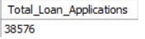
MTD Loan Applications
SELECT COUNT(id) AS MTD_Total_Loan_Applications FROM bank_loan
WHERE MONTH(issue_date) = 12 AND YEAR(issue_date) = 2021;
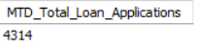
PMTD Loan Applications
SELECT COUNT(id) AS PMTD_Total_Loan_Applications FROM bank_loan
WHERE MONTH(issue_date) = 11 AND YEAR(issue_date) = 2021;
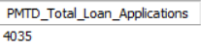

Total Funded Amount
SELECT SUM(loan_amount) AS Total_Funded_Amount FROM bank_loan;
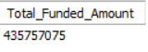

MTD Total Funded Amount
SELECT SUM(loan_amount) AS MTD_Total_Funded_Amount FROM bank_loan
WHERE MONTH(issue_date) = 12 AND YEAR(issue_date) = 2021;
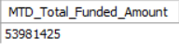

PMTD Total Funded Amount
SELECT SUM(loan_amount) AS PMTD_Total_Funded_Amount FROM bank_loan
WHERE MONTH(issue_date) = 11 AND YEAR(issue_date) = 2021;
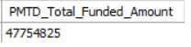

Total Amount Received
SELECT SUM(total_payment) AS Total_Amount_Received FROM bank_loan;
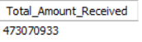

MTD Total Amount Received
SELECT SUM(total_payment) AS MTD_Total_Amount_Received FROM bank_loan
WHERE MONTH(issue_date) = 12 AND YEAR(issue_date) = 2021;
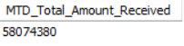

PMTD Total Amount Received
SELECT SUM(total_payment) AS PMTD_Total_Amount_Received FROM bank_loan
WHERE MONTH(issue_date) = 11 AND YEAR(issue_date) = 2021;
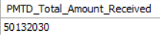

Average Interest Rate
SELECT ROUND(AVG(int_rate) * 100, 2) AS Avg_Interest_Rate FROM bank_loan;
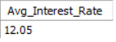
MTD Average Interest Rate
SELECT ROUND(AVG(int_rate) * 100, 2) AS MTD_Avg_Interest_Rate FROM bank_loan
WHERE MONTH(issue_date) = 12 AND YEAR(issue_date) = 2021;
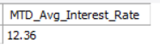
PMTD Average Interest Rate
SELECT ROUND(AVG(int_rate) * 100, 2) AS PMTD_Avg_Interest_Rate FROM bank_loan
WHERE MONTH(issue_date) = 11 AND YEAR(issue_date) = 2021;
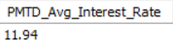
Average DTI
SELECT ROUND(AVG(dti) * 100, 2) AS Avg_DTI FROM bank_loan;
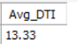
MTD Average DTI
SELECT ROUND(AVG(dti) * 100, 2) AS MTD_Avg_DTI FROM bank_loan
WHERE MONTH(issue_date) = 12 AND YEAR(issue_date) = 2021;
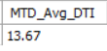

PMTD Average DTI
SELECT ROUND(AVG(dti) * 100, 2) AS PMTD_Avg_DTI FROM bank_loan
WHERE MONTH(issue_date) = 11 AND YEAR(issue_date) = 2021;
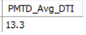

GOOD LOAN ISSUED
Good Loan Percentage
SELECT
ROUND(COUNT(CASE WHEN loan_status = 'Fully Paid' OR loan_status = 'Current' THEN id END) * 100 / COUNT(id) ,2) AS Good_Loan_Percentage
FROM bank_loan;
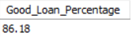

Good Loan Applications
SELECT COUNT(id) AS Good_Loan_Applications FROM bank_loan
WHERE loan_status IN ('Fully Paid', 'Current')
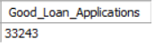

Good Loan Funded Amount
SELECT SUM(loan_amount) AS Good_Loan_Funded_Amount FROM bank_loan
WHERE loan_status IN ('Fully Paid', 'Current');
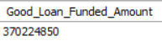

Good Loan Total Received Amount
SELECT SUM(total_payment) AS Good_Loan_Received_Amount FROM bank_loan
WHERE loan_status IN ('Fully Paid', 'Current');
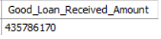

BAD LOAN ISSUED
Bad Loan Percentage
SELECT
ROUND(COUNT(CASE WHEN loan_status = 'Charged Off' THEN id END) * 100.0 / COUNT(id), 2) AS Bad_Loan_Percentage
FROM bank_loan;
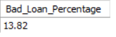

Bad Loan Applications
SELECT COUNT(id) AS Bad_Loan_Applications FROM bank_loan
WHERE loan_status = 'Charged Off';
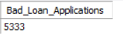

Bad Loan Funded Amount
SELECT SUM(loan_amount) AS Bad_Loan_Funded_Amount FROM bank_loan
WHERE loan_status = 'Charged Off';
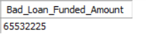

Bad Loan Total Received Amount
SELECT SUM(total_payment) AS Bad_Loan_Received_Amount FROM bank_loan
WHERE loan_status = 'Charged Off';
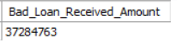

Loan Status
SELECT
loan_status,
COUNT(id) AS Total_Loan_Applications,
SUM(total_payment) AS Total_Amount_Received,
SUM(loan_amount) AS Total_Funded_Amount,
AVG(int_rate * 100) AS Interest_Rate,
AVG(dti * 100) AS DTI
FROM
bank_loan
GROUP BY
loan_status;

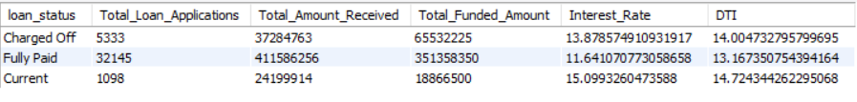
MTD Loan Status
SELECT
loan_status,
SUM(total_payment) AS MTD_Total_Amount_Received,
SUM(loan_amount) AS MTD_Total_Funded_Amount
FROM bank_loan
WHERE MONTH(issue_date) = 12 AND YEAR(issue_date) = 2021
GROUP BY loan_status;

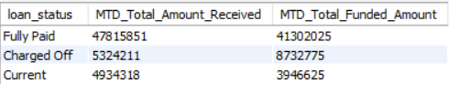
PMTD Loan Status
SELECT
loan_status,
SUM(total_payment) AS PMTD_Total_Amount_Received,
SUM(loan_amount) AS PMTD_Total_Funded_Amount
FROM bank_loan
WHERE MONTH(issue_date) = 11 AND YEAR(issue_date) = 2021
GROUP BY loan_status;

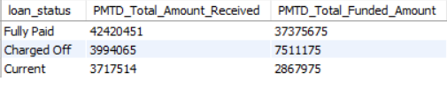

- BANK LOAN REPORT | OVERVIEW
MONTH
SELECT
MONTH(issue_date) AS Month_Number,
MONTHNAME(issue_date) AS Month_Name,
COUNT(id) AS Total_Loan_Applications,
SUM(total_payment) AS Total_Amount_Received,
SUM(loan_amount) AS Total_Funded_Amount
FROM bank_loan
GROUP BY MONTH(issue_date), MONTHNAME(issue_date)
ORDER BY MONTH(issue_date);
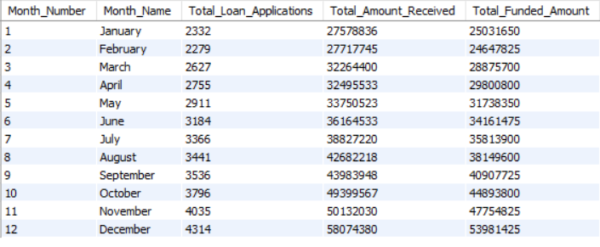
STATE
SELECT
address_state,
COUNT(id) AS Total_Loan_Applications,
SUM(total_payment) AS Total_Amount_Received,
SUM(loan_amount) AS Total_Funded_Amount
FROM bank_loan
GROUP BY address_state
ORDER BY SUM(total_payment);
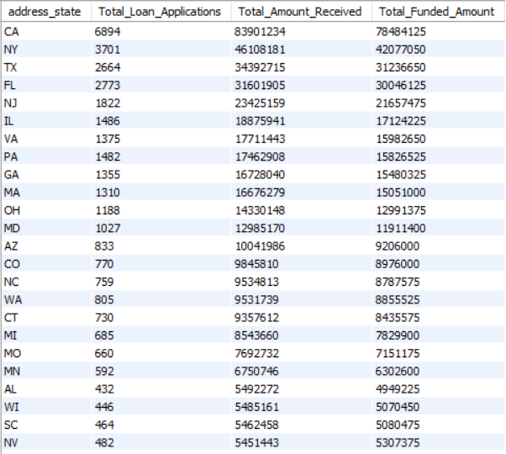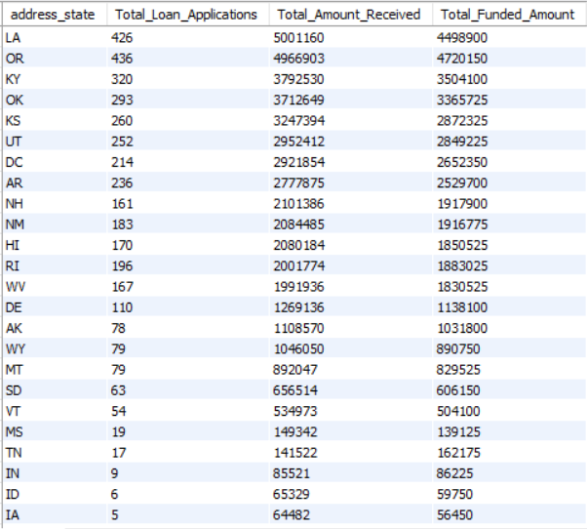
TERM
SELECT
term,
COUNT(id) AS Total_Loan_Applications,
SUM(total_payment) AS Total_Amount_Received,
SUM(loan_amount) AS Total_Funded_Amount
FROM bank_loan
GROUP BY term
ORDER BY term DESC;
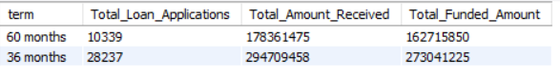
EMPLOYEE LENGTH
SELECT
emp_length,
COUNT(id) AS Total_Loan_Applications,
SUM(total_payment) AS Total_Amount_Received,
SUM(loan_amount) AS Total_Funded_Amount
FROM bank_loan
GROUP BY emp_length
ORDER BY COUNT(id) DESC;
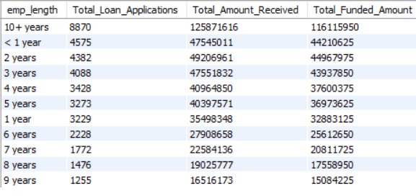
PURPOSE
SELECT
purpose,
COUNT(id) AS Total_Loan_Applications,
SUM(total_payment) AS Total_Amount_Received,
SUM(loan_amount) AS Total_Funded_Amount
FROM bank_loan
GROUP BY purpose
ORDER BY COUNT(id) DESC;
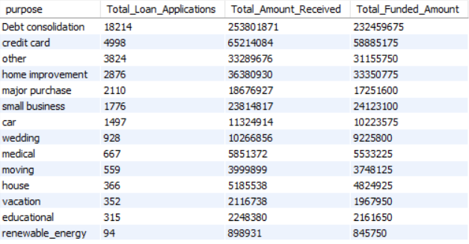
HOME OWNERSHIP
SELECT
home_ownership,
COUNT(id) AS Total_Loan_Applications,
SUM(total_payment) AS Total_Amount_Received,
SUM(loan_amount) AS Total_Funded_Amount
FROM bank_loan
GROUP BY home_ownership
ORDER BY COUNT(id) DESC;
